

**The Current Workforce**

Retirement, Replacement & Recruitment Eastern Illinois Chapter & Local 176 .

-

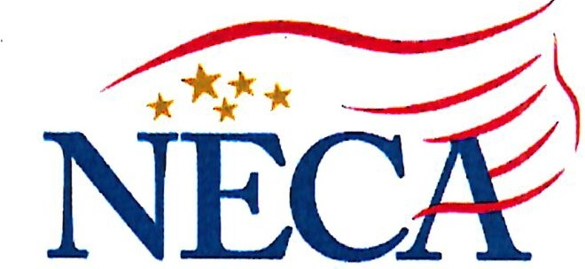

**NATIONAL ELECTRICAL CONTRACTORS ASSOCIATION**

**Workforce Snapsho**_ **t**

1. The slide includes:
   1. The number of Journeymen in this jurisdiction in the 1st quarter of 2022
   2. The number of Apprentices, Construction Wiremen, Construction Electricians and Others was provided by local parties in July 2022, unless otherwise noted.

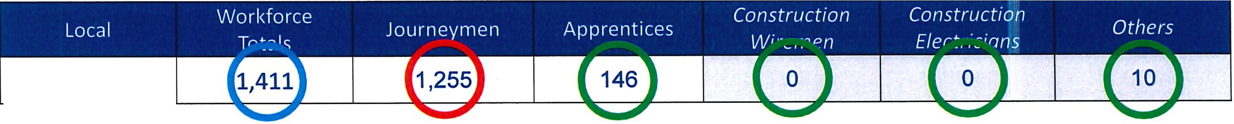

Local176

SLIDE #2

---

**NECA**

Journeymen & Apprentices

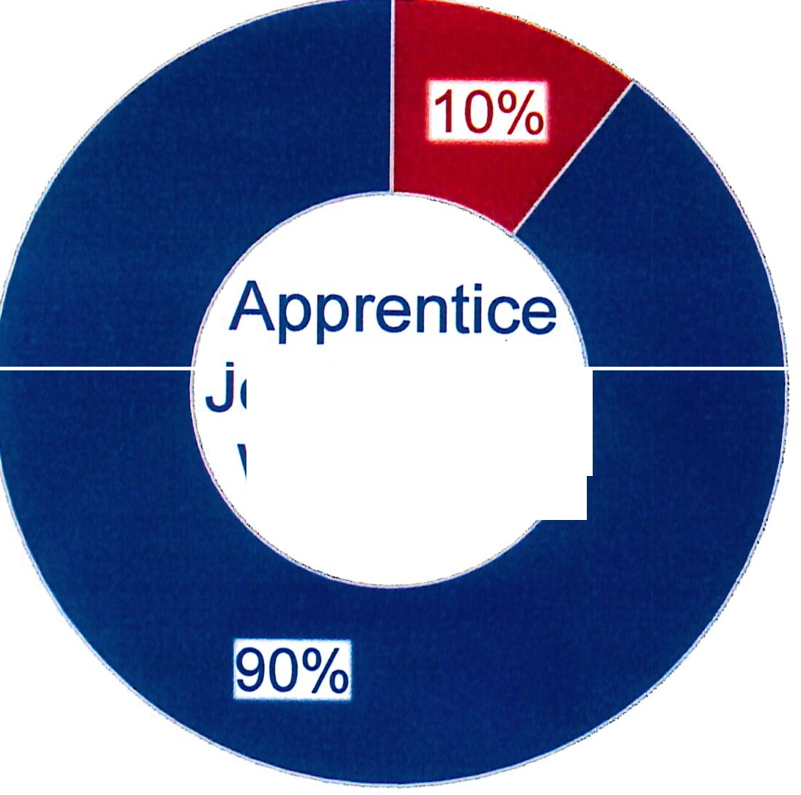

Journeyman Workforce}

*���*

Journeymen - 1255

Apprentices - 146 JW to APP Ratio - 9:1

@ Journeymen @ Apprentices

suoE #3 Workforce - Summer 2022 NECA

|  |  |  |  |  |  |
| --- | --- | --- | --- | --- | --- |
| Our Aging Workforce - *Source: NEBF 1st Quarter* 2022 | | | | | |
| **Local Union** | **Available Journeymen** | **Over60** | **Over 55**  **Under 60** | **Over50 Under 55** | **Total Over 50 Years Old** |
| **Local176** | **1255** | **113** | **258** | **293** | **664** |

|  |  |  |  |  |  |
| --- | --- | --- | --- | --- | --- |
| Imminent Retirees - *Source: NEBF 1st Quarter�022* | | | | | |
| **65-64** | **63-62** | **61** - **60** | **59 -58** | **57-56** | **Estimated**  **Imminent Retirees** |
| **15** | **47** | **88** | **105** | **109** | **364** |

suoE#4 Retirements and Replacements NECA

|  |  |  |  |  |  |
| --- | --- | --- | --- | --- | --- |
| Indentured Apprentices - *Source: NECA Field Staff* - *July 2022* | | | | | |
| 5th Period | 4th Period | 3rd Period | 2nd Period | 1st Period | Total in Program |
| 22 | 23 | 23 | 31 | 47 | **146** |

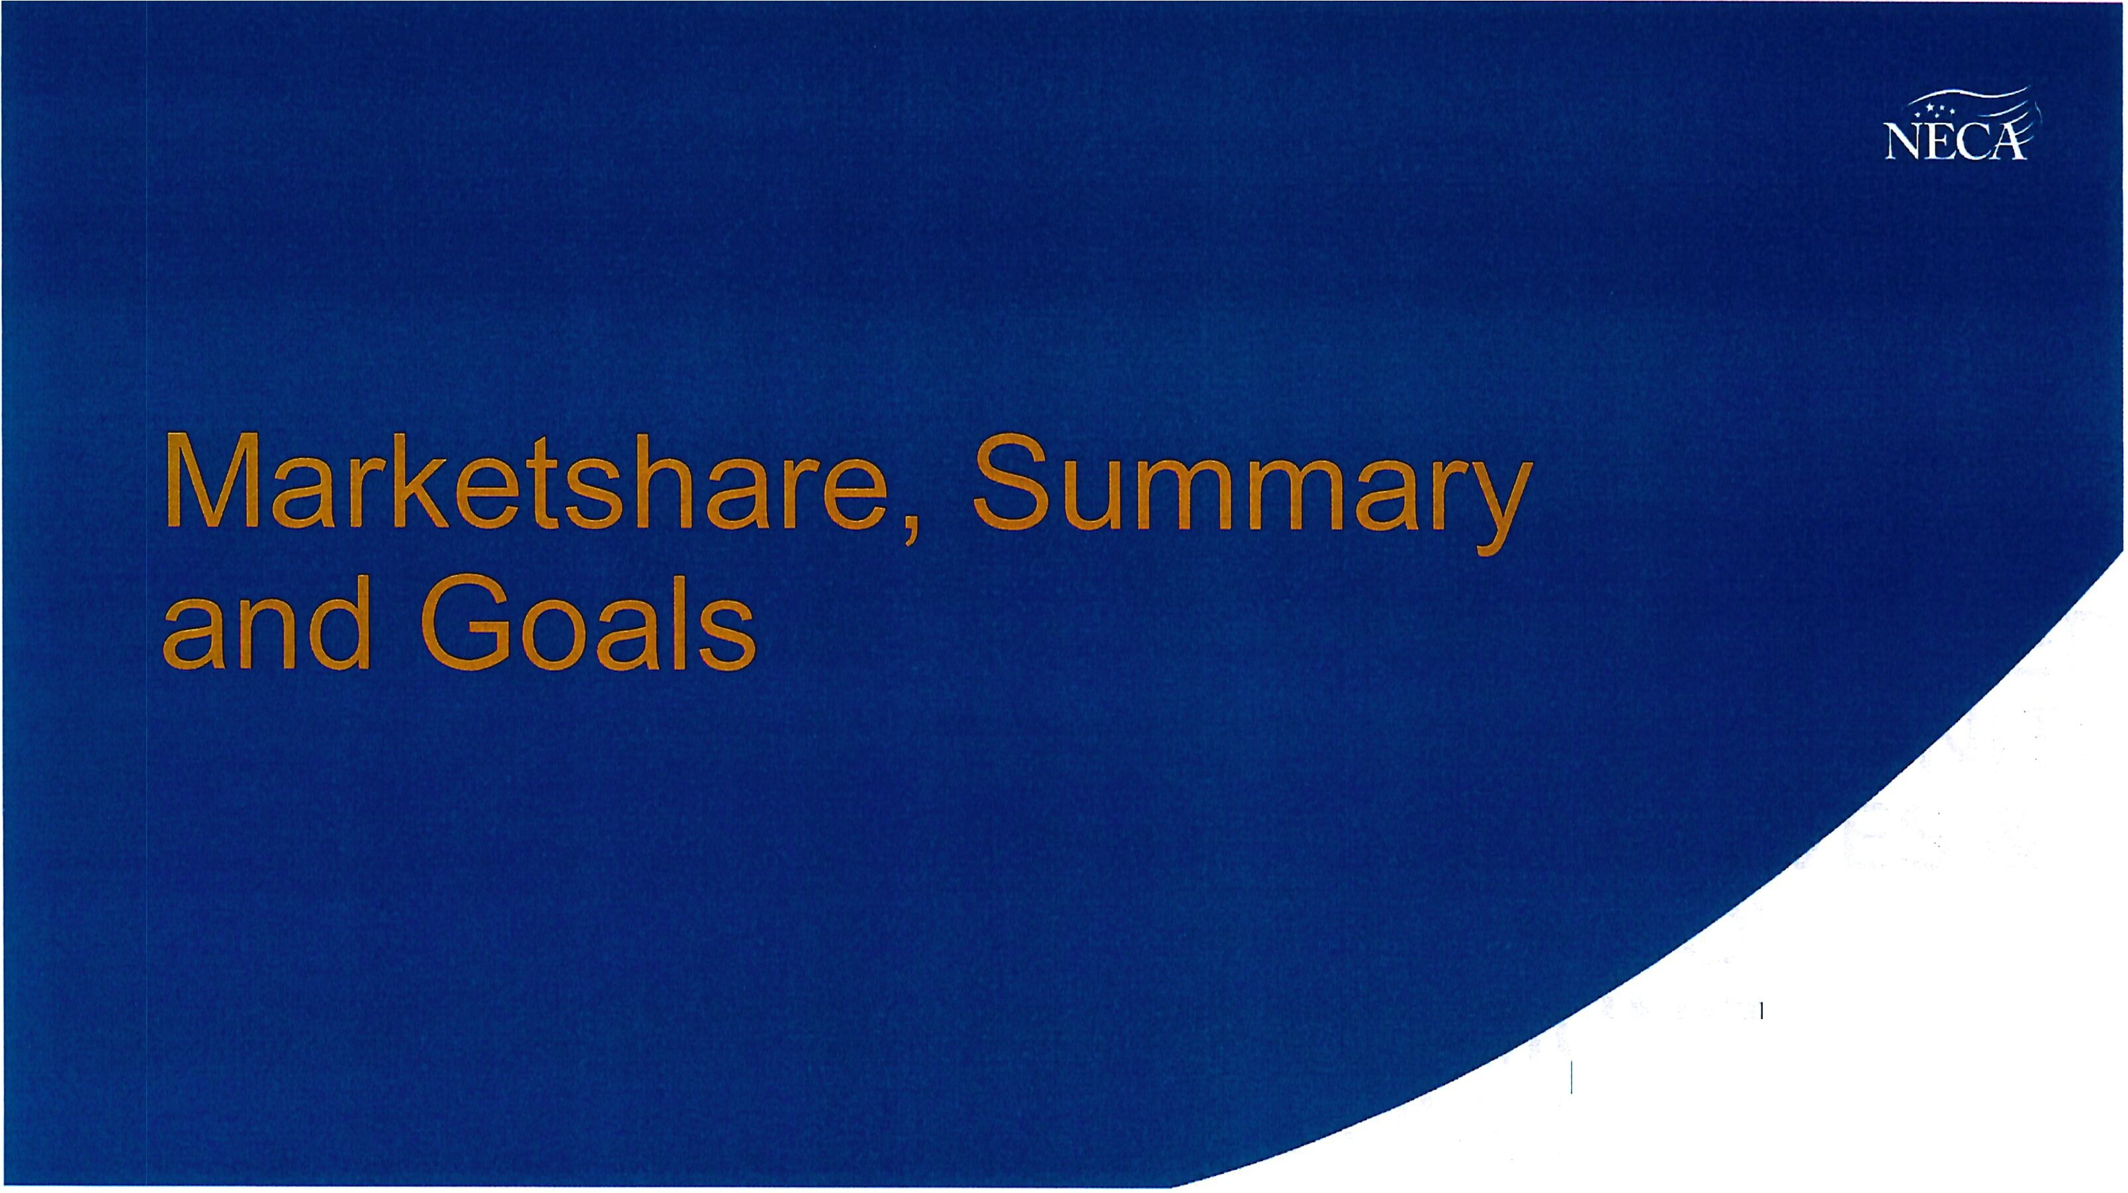

EMPOWERING LIVES & COMMUNITIES

|  |  |  |  |  |  |
| --- | --- | --- | --- | --- | --- |
| Local Union | IBEW  Employment | Non-Union Employment | Industry Employment | Employment Marketshare | Trending Marketshare |
| Local176 | 1,319 | 261 | 1,580 | 83% | 83% |



**Local 176**

100%

90%

80%

**87%**

**89%**

**84%**

**85%**

**B:J'Vc;**

**83%**

**83%**

70%

60%

50%

**:ZG t**

**73%**

***74"***

**80%**

**75%**

**71%**

-- **73%** -

**70%**

**67%**

**69%**

**64%-**

40%

30%

20%

-

-

-

-

10%

0%

2004

2005

2006

2007

2008

2009

2010

2011

2012

2013

2014

2015

2016

2017

2018

2019

2020

2021

suoE#6 2020 NLMCC Marketshare and Trending NECk

# Marketshare Summary

* 1,580 Industry
  + 1,319 Union
  + 261 non-Union

# Recruitment and Growth Goals

* Add workers to the unionized sector
* Update apprenticeship standards
* Increase employment of apprentices, journeymen and others
* Renew efforts to recruit and organize non-Union workers and employers

----

**NECA**-

SLIDE #7